**WiiM Shakes Up Custom Install Market   
with Two High-Performance Game Changers**

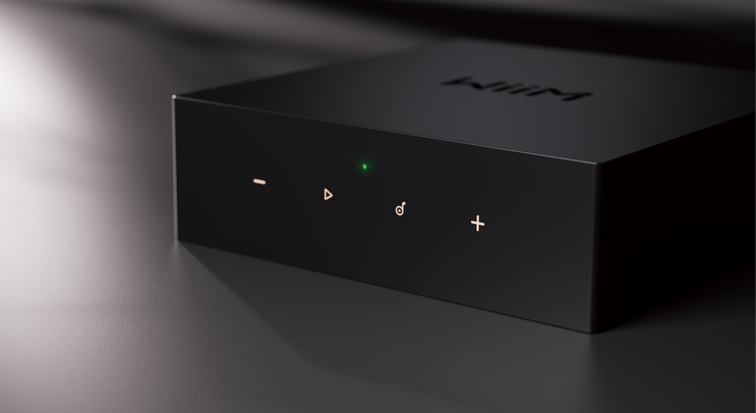

Above: WiiM CI MOD S

**Didcot, Oxfordshire, 18 September 2024—**WiiM, the smart home streaming specialist exclusively distributed in the United Kingdom by Henley Audio, is debuting its product range for the custom install market.Part of the Newark, CA-based Linkplay Technologies group, WiiM’s product announcements for 2024 already include the home-user-oriented WiiM Amp Pro and WiiM Ultra. With the introduction of the WiiM CI MOD A80 amplifier and WiiM CI MOD S streamer, WiiM is expanding its innovative solutions for professional buyers.

The WiiM CI MOD A80 combines an ESS ES9018K2M SABRE Reference DAC with a TI TPA3255 Class-D stereo amplifier, delivering 60W per channel at 8 ohms. It supports the latest Wi-Fi 6E and Bluetooth 5.3 technologies. The WiiM CI MOD S is an audiophile-grade streamer featuring an AKM AK4493SEQ DAC with hi-res audio support up to 24-bit/192kHz. At launch, supported control platforms will include Control 4, RTI, URC and Josh.ai. Like other WiiM products, both devices also feature extensive hardware connectivity options.

The WiiM CI MOD A80 and MOD S will make their exclusive UK debut at EI Live!, the leading AV and home integration trade show, on September 18-19 at the Farnborough International Exhibition Centre. For more information, visit [www.eiliveshow.com](https://eiliveshow.com/). Further details on the new WiiM models, including full specifications, will be unveiled at the event and at [www.henleyaudio.co.uk/wiim-ci/](http://www.henleyaudio.co.uk/wiim-ci/). Henley Audio will announce UK pricing and availability before the end of the year.

Download high-resolution images here: <https://we.tl/t-SIh6XfTCUF>.

**Ends.**

**About Henley Audio**

Henley Audio has been importing and distributing industry-leading hi-fi equipment to the UK and Ireland since 1997. With a passion for great sound and a firm focus on brand integrity, we work to deliver excellence in both product and service. Formed as the result of a management buy-out of Ortofon UK, Henley Designs Ltd. (trading as Henley Audio) operates in-house sales, marketing, service, support, and warehouse teams to offer the full turn-key solution for suppliers. The brands we represent are highly regarded and share a symbiotic relationship with other brands in our portfolio.

For more information, visit: [www.henleyaudio.co.uk](http://www.henleyaudio.co.uk)

**About WiiM:**

WiiM brings premium smart home experiences through simple and affordable connected AI products. With its patented audio streaming, smart home solution, and innovative voice user interface built into its high-quality products and app, users can effortlessly play music and control their devices throughout the home. All WiiM products feature the finest product design and intuitive user interface and are based on WiiM OS. Developed by Linkplay, WiiM's parent company, WiiM OS powers over 10 million smart audio and smart home products.

For more information, visit: <https://wiimhome.com>