FOR IMMEDIATE RELEASE

Klipsch Music City Series puts
portable Bluetooth speakers on the map
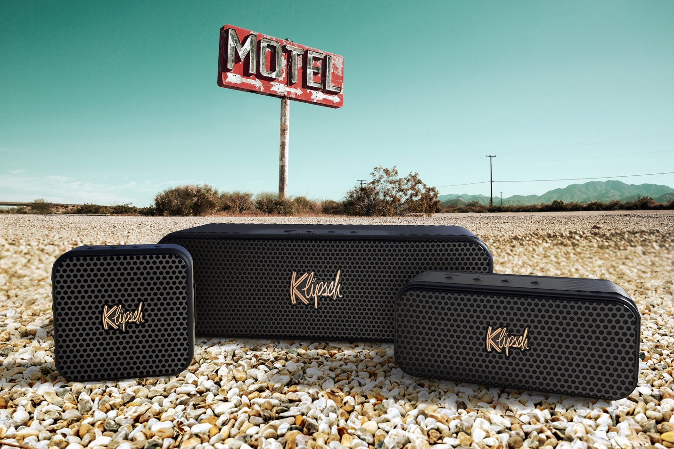
Didcot, Oxfordshire (29 November 2023) – Henley Audio proudly announces the UK launch of the Klipsch Music City Series. Comprising the Klipsch Austin, Klipsch Nashville and the Klipsch Detroit, the US maker's new fleet of portable Bluetooth speakers has been inspired by the legendary artists and musical genres of iconic American music cities. The first model to land in the UK is the Klipsch Nashville.

The Nashville is the middle child, featuring a dual 2.25-inch driver system backed by a pair of passive radiators and good for up to 24 hours of Dolly, Kitty, and Taylor. All three models rate IP67, making them ideal for the tour bus and even a (quick) splash in the motel pool. Klipsch Broadcast Mode, which allows you to connect more than ten compatible speakers at once, features throughout the Music City Series.

The little Austin is super portable – paying respect to its namesake's fame for live music – yet supplies up to 12 hours of big-sounding music from its single 1.5-inch driver and twin passive radiator array. The big Detroit motors on for up to 24 hours and packs dual three-inch drivers, a 1-inch tweeter and quad force cancelling passive radiators under its 33cm-wide hood.

Key features of the Klipsch Music City Series include:
- Bluetooth 5.3: All Music City models tote the latest version of 5.3, allowing you to move the speaker up to 40 feet from the music source.
- Broadcast Mode: This lets you connect to more than ten Klipsch Broadcast Mode-capable speakers simultaneously to create an immersive sound experience.
- Built-in mic: The integrated mic allows you to pause music to take a call without searching for your smartphone.
- Dust and Waterproof: All models are rated at IP67, meaning the Music City speakers are protected from dust and submergible in up to one meter of water for 30 minutes.
- Klipsch Connect app: The speakers work with the Klipsch Connect App, which brings custom EQ settings and over-the-air firmware updates.
- Long-lasting battery: The Detroit and Nashville deliver up to 24 hours of playtime, and the little Austin is good for up to 12 hours of replay.
Klipsch has a history of delivering high-quality audio experiences, and the Music City Series continues this tradition with a fresh twist. "Our Klipsch Music City Series is a celebration of music and culture. We wanted to pay homage to some of the most influential cities that have shaped the world of music, and we did so by crafting speakers that not only sound incredible but also embody the essence of Austin, Nashville, and Detroit," said Paul Jacobs, President, and CEO of Klipsch.

The Klipsch Nashville rolls into UK stores in December, priced at £159.00. The Klipsch Austin and Detroit models are set to land in the UK in early 2024.

Henley Audio distributes Klipsch in the UK. For more information about the Klipsch Music City Series, please visit www.henleyaudio.co.uk.
###

Klipsch Music City Series Specification
 | Klipsch Austin | Klipsch Nashville | Klipsch Detroit
360º sound | • | ü | •
Battery life | 12 hours | 24 hours | 24 hours
Bluetooth version | 5.3 | 5.3 | 5.3
Broadcast Mode | ü | ü | ü
Dimensions (HWD) | 105 x 105 x 44 mm | 78 x 178 x 81 mm | 105 x 333 x 122 mm
Rates IP67 | ü | ü | ü
Klipsch Connect app | ü | ü | ü
Strap/handle | ü | • | ü
USB-C charging | ü | ü | ü
Weight | 397 g | 970 g | 2500 g
Driver configuration | Single 1.5-inch  + dual passive radiators | Dual 2.25-inch  + dual passive radiators | Dual 3-inch drivers  + dual 1-inch tweeters  + quad force cancelling passive radiators

About Klipsch Audio
In 1946, Paul W. Klipsch, inventor, acoustics pioneer and maverick, founded Klipsch Audio with the sole purpose of bringing the power, detail, and emotion of the live music experience into his living room. Using highly efficient speaker designs, handcrafted cabinetry, and a thirst for real engineering breakthroughs – Klipsch, the great American loudspeaker company, was born in Hope, AR. Today, its diverse range of quality audio products includes speakers and headphones for almost any consumer and professional application – including cinema, whole-house, wireless, home theatre and portable offerings. Honouring its founder's legacy, Klipsch continues to be the legendary high-performance brand of choice for audiophiles and aficionados around the world. Klipsch is the 'Keepers of the Sound'.
Klipsch is a trademark of Klipsch Group, Inc., registered in the US and other countries. Klipsch Group, Inc. is a VOXX International Company (NASDAQ: VOXX).
For more information, visit www.klipsch.com
About Henley Audio
Henley Audio has been importing and distributing industry-leading hi-fi equipment to the UK and Ireland since 1997. With a passion for great sound and a firm focus on brand integrity, it works to deliver excellence in both product and service. Formed as the result of a management buy-out of Ortofon UK, Henley Designs Ltd. (trading as Henley Audio) operates in-house sales, marketing, service, support, and warehouse teams to offer the full turn-key solution for suppliers. The brands it represents are highly regarded and share a symbiotic relationship with other brands in its portfolio.
For more information, visit www.henleyaudio.co.uk.
Henley Audio UK Press Contact
Murdo Mathewson, Ginger Dog Comms
murdo@gingerdogcomms.com
+44 (0)7960 018147

