WiiM Pro, the Versatile Audiophile-Grade Music Streamer, Receives 'Roon Ready' Certification

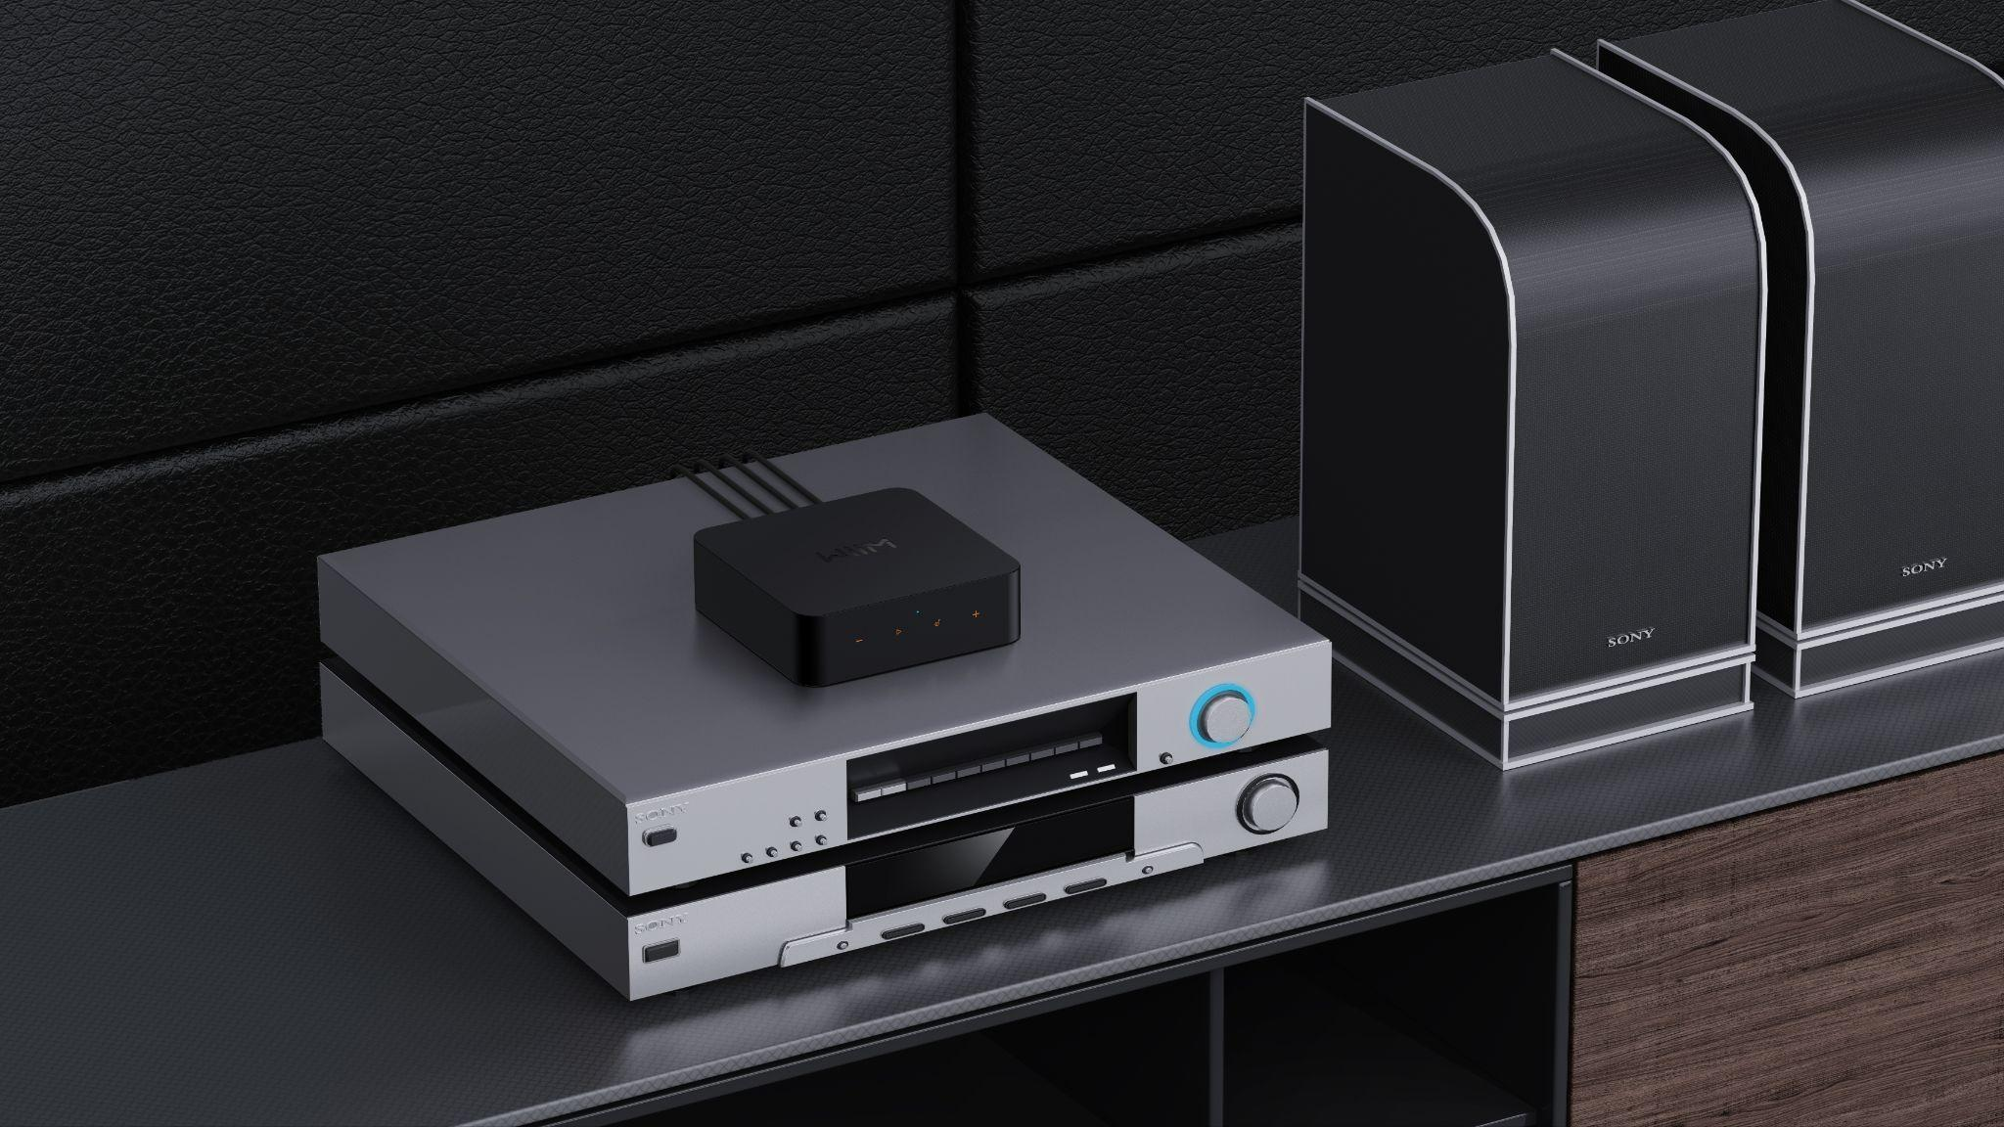

WiiM Pro Receives Coveted "Roon Ready" Certification, Elevating User's Audio Streaming Experience

Newark, CA - June 30, 2023 - Linkplay Technology Inc., the global technology company offering premium smart home experiences through simple and affordable connected AI products, is proud to announce that the WiiM Pro has received the Roon Ready certification from Roon Labs. The WiiM Pro, launched by the brand earlier this year, is a versatile, audiophile-grade Hi-Res music streamer that turns any analogue audio equipment into a smart, network-connected system with Wi-Fi or Ethernet, allowing users to modernize their favourite equipment for a fraction of the cost of buying a new setup.

"We are thrilled to achieve the Roon Ready certification for the WiiM Pro," said Lifeng Zhao, CEO of Linkplay Technology. "This certification reinforces our commitment to enriching the audio experience for our valued customers. The seamless integration with Roon takes the WiiM Pro to new heights, allowing users to explore and savour their favourite music with unparalleled sound quality."
Roon is a rich and engaging way to browse, organize and listen to music. Artist photos, credits, bios, reviews, lyrics, tour dates and composers are located automatically, then interconnected by links to build a surfable digital magazine. Through Roon Ready, the WiiM Pro offers a multi-room, multi-user networked audio platform featuring bit-perfect playback, DSD and PCM upsampling, multichannel support and Signal Path display.

What does it mean to be Roon Ready?
WiiM Pro streamers transparently discover and connect to Roon without any configuration and deliver bit-perfect audio from Roon to the streamer. Together, Roon and WiiM deliver networked audio's power, flexibility and performance with the easiest setup and highest reliability available. It runs on most Mac, Windows, and Linux PCs or other products, including Roon Core.

Pricing and Availability
The WiiM Pro is available now with its Roon Ready features for $149 on Amazon. Existing WiiM Pro users will receive an over-the-air update notification to enable Roon Ready on their devices. For more information about the WiiM Pro or other WiiM products, please visit www.wiimhome.com.

Images, specs, and more are in the press kit here.

###
About Roon Labs
Roon transforms the experience of browsing music. Artist photos, credits, bios, reviews, lyrics, tour dates, and composers are located automatically and then interconnected by links to build a surfable, searchable digital magazine about your entire music collection.

Roon also links all of your personal files with the millions of tracks available on TIDAL and Qobuz, so you can start with the music you know and then explore and discover new music from the world beyond your collection. Roon runs on most Mac, Windows, and Linux PCs as a server, with an Android or iOS smartphone/tablet used as a control point.

About Linkplay Technology
Linkplay Technology was established in 2014 by a core team of high-calibre technology entrepreneurs from Google, Broadcom, InterVideo and Harman. They developed cutting-edge wireless technology, software, hardware and more for a variety of voice and smart product global brands in various markets, powering over 10 million smart audio and smart home products.

Media Contact
Max Borges Agency for WiiM
wiim@maxborgesagency.com

