WiiM launches its debut streaming amplifier
The WiiM Amp packs digital amplification and hi-res streaming capabilities into a smart little box

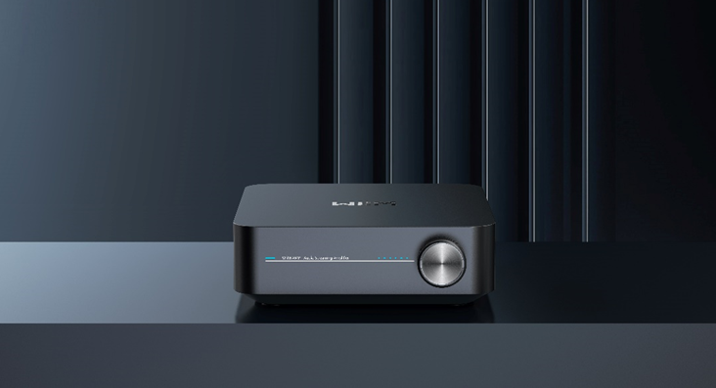
Above: WiiM Amp

Didcot, Oxfordshire, 22 November 2023 – WiiM announces the WiiM Amp, its first streaming amplifier. The WiiM Amp delivers hi-res and lossless quality while enabling multiroom functionality and connection to the latest audio technologies. Users can connect WiiM Amp to their passive speakers, home theatre set-up or vintage record player (just add a phono stage) and stream their music collection directly from a preferred music app or by voice commands. Henley Audio exclusively distributes WiiM in the UK.

"We've dedicated ourselves to designing products that elevate the music streaming experience, and the WiiM Amp is the first step in our expanded line-up," said Dr Lifeng Zhao, CEO of WiiM. "With valuable user feedback and our team's commitment to superior audio quality, the WiiM Amp delivers audiophile-grade sound and a seamless experience for music enthusiasts to unlock a world of musical possibilities."

Versatile Streaming Amplifier
Featured specs of WiiM Amp include:

- Powerful Delivery: Class-D amplifier packing 60 Watts per channel (8 ohms) or 120 Watts per channel (4 ohms) delivers high-fidelity sound to even the most demanding speakers, up to four on a single amplifier. The WiiM Amp merges a high-quality streamer with a superior TI 3255 amplifier chip.
- Audio Input: Features analogue (RCA), digital optical port, HDMI ARC and up to 24-bit/192 kHz of gapless playback of high-res music to bring your TV audio, record player, CD player or other audio source into the digital world.
- Audio Output: Up to 192 kHz/ 24-bit, varying sample rate and bit depth based on the audio source without resampling.
- Two banana plugs:
- SNR: 99 dB
- THD+N (1 kHz), 5W/8 Ohms: -95 dB
- Subwoofer Out: Offers automatic bass management when paired with an external subwoofer, elevating sound quality.
- USB Host for Storage: Access personal media library and use it as a media server for other WiiM smart devices.
- Optimal Sound Performance: Various EQ and Parametric EQ options enhance sound to suit individual preferences, speakers, and different listening environments. Includes 24 pre-set EQ settings, 10-band graphic EQ adjustable to every audio source (line-in, Bluetooth, or network) and 4-band parametric EQ that allows fine granular adjustments.
- Connectivity and power
- AC 100-240v input
- Bluetooth 5.0 with Bluetooth Low Energy (BLE) supports both A2DP receiver and transmitter, AVRCP, HID, works with the WiiM Voice Remote
- Ethernet, 10M/100 Mbps
- Straightforward TV connectivity with HDMI ARC
- USB Host – connect to USB disk for local music playback
- Wi-Fi 5, 802.11 b/g/n/ac 2.4 GHz and 5 GHz dual band

Connect Your Home Audio Affordably
The WiiM Amp caters to those seeking to optimize beloved, decades-old, high-quality audio systems and those looking to use their classic passive speakers with their favourite platforms effortlessly. By seamlessly connecting your audio gear to the WiiM Amp, you can control your streaming from the comfort of the WiiM Home App. The WiiM Voice Remote controller provides another stress-free form of wireless control for the WiiM Amp.

Compatible with your Favourites
WiiM Amp lets users stream their favourite music, TV audio, radio, podcasts and more from iOS, MacBook, and Apple TV. It supports Apple AirPlay 2, Google Chromecast, Alexa Music Cast, Deezer, Qobuz, Pandora, DLNA, Spotify Connect, and TIDAL HiFi and HiFi+, which lets you cast YouTube Music, TV audio, radio stations, podcasts, and local content directly from Chromecast-enabled Apps. Since it works with Siri, Alexa, and Google, you can choose your preferred voice assistants to control music selection, volume, and playback.

Make Set Up Easy
The WiiM Amp pops up automatically in the WiiM Home app. Thanks to the simple in-app guide and compact size, device set-up can take less than two minutes.

Always Getting Smarter
The WiiM Amp is constantly learning and improving. With the frequent software updates, Roon Ready certification expected soon, and automatic OTA, it only gets even better with time.

Pricing and Availability
The WiiM Amp launches in the UK this month, priced at £299.00. ($299.00 / €349.00.) Other WiiM products like the WiiM Pro and WiiM Pro Plus multiroom-capable streamers can pair with the WiiM Amp to deliver a seamless smart-home experience. Henley Audio exclusively distributes WiiM in the UK. For more information, please visit www.henleyaudio.co.uk/brands/wiim.

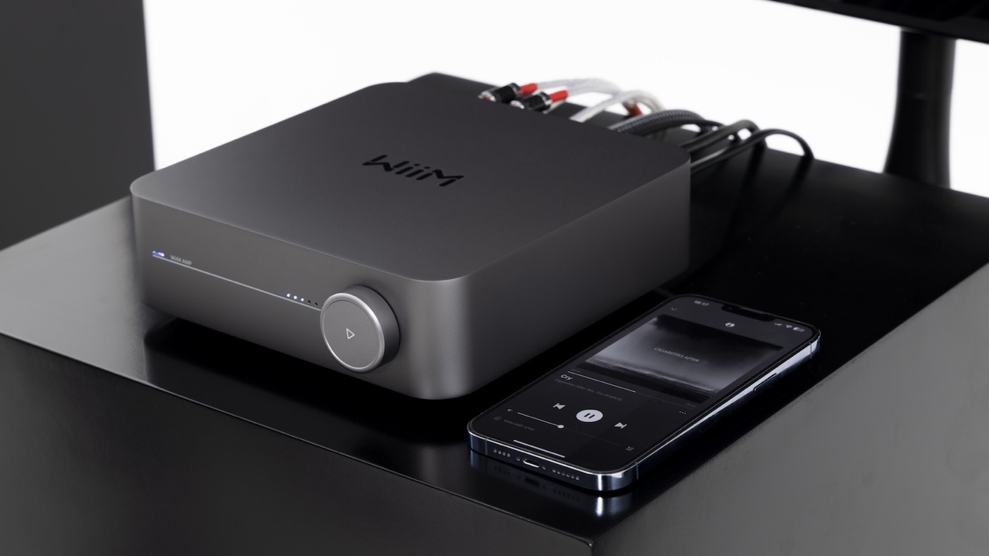
Above: WiiM Amp with a smartphone running WiiM Home App

Ends.

About Henley Audio
Henley Audio has been importing and distributing industry-leading hi-fi equipment to the UK and Ireland since 1997. With a passion for great sound and a firm focus on brand integrity, we work to deliver excellence in both product and service. Formed as the result of a management buy-out of Ortofon UK, Henley Designs Ltd. (trading as Henley Audio) operates in-house sales, marketing, service, support, and warehouse teams to offer the full turn-key solution for suppliers. The brands we represent are highly regarded and share a symbiotic relationship with other brands in our portfolio.

For more information, visit: www.henleyaudio.co.uk

About WiiM:
WiiM brings premium smart home experiences through simple and affordable connected AI products. With its patented audio streaming, smart home solution, and innovative voice user interface built into its high-quality products and app, users can effortlessly play music and control their devices throughout the home. All WiiM products feature the finest product design and intuitive user interface and are based on WiiM OS. Developed by Linkplay, WiiM's parent company, WiiM OS powers over 10 million smart audio and smart home products.

For more information, visit: https://wiimhome.com

